Name: lim siew fang__
Login ID:limsiewfang @oasis-portal.com_
Course title: Tourism and hospitality_
Subject Code: BHM04 Submitted date: 11/9/2017

Table of Contents
No | Details | Page
1 | Executive Summary | 1
2 | Introduction | 2
3 | Assignment Question
 | Part 1 | 3-4
 | Part 2 | 5-9
 | Part 3 | 10-12
 | Part 4 | 13-15
4 | Conclusion | 16
5 | References | 17
 | Appendix | 18

Excutive summary
This assignment is to be really understanding in tourism and hospitality.The fisrt part I want to tall about meaning of tourism and hospitality.The second part,explain about hospitality industry and show some example for better as well understanding this part.In order,question 2 is explain based on different type og tourism categories.Thirdly,talk about lodging accommodation and research many type of hotel accommodation .The last question is explain significant of entertainment in this industry and relevant examples of entertainment sector in hospitality.

Introduction
Tourism is one of the most flourishing industries in the world,making a singnificant to the world.Many people from arcoss global travel miles and miles away from their home ,in order to see and experience their culture.while tourism is one of business of providing tour and services for tourist .Hospitality also providing for individual or group traveling away from home.

Question 1 Define the tourism and hospitality. Tourism is a group service and industry activities that provide a travel experience comparable to travel.Retailers provide food and beverages,retail businesses for entertainment and other services to individuals or group traveling.Furthermore,tourism is a social,cultural and economic phenomenon that involves mobility for personal ,professional ,or business mobility.

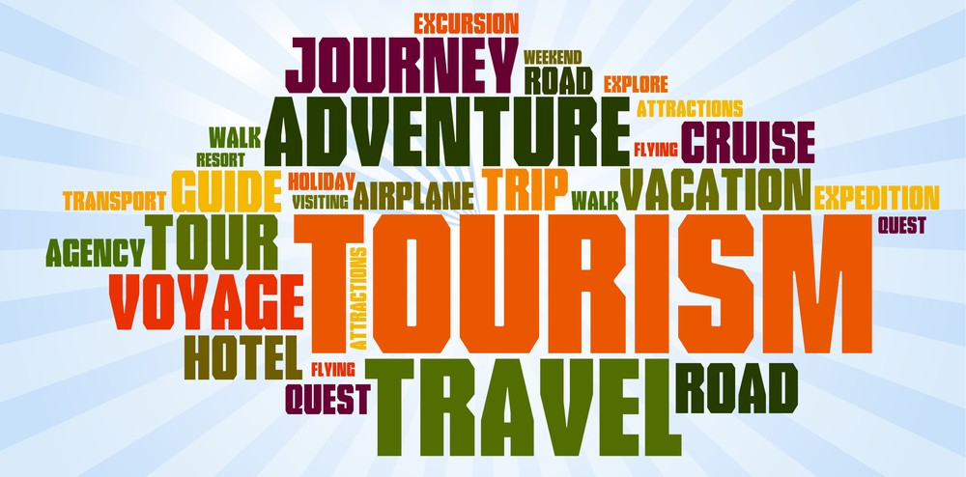
Figure 1:type of tourism

Hospitality is a business like any other at the heart of this business is desire to service.The definition of hospitality for a wide range of hotels and restaurants extends to restaurants and hotel .there are also organization that provide shelter and other services to those who are away from home .The format is still true.


What is hospitality industry?The hospitality industry is a broad category of fields within service industry that includes the lodging,event planning,theme parks ,transportation and cruise line.
Lodging is vacation accommodation is a type of accommodation that travels and stays more than a day from home ,necessitates rest,sleep,food ,shelter from cold temperatures,or luggage that rains and reaches home function.

Event planning it is a process of project management, such as meetings,conventions,exhibitions,rituals,team building,parties,or conventions.

Theme park it is a large outdoor area where people pay to enjoy themselves.Activities in theme parks ofthen follow a particular theme or theme.

Question2 Brief on different type of tourism categories. Leisure travel is also referred to as travel or holiday travel as a type of travel when tourists go vacation.Travelers looking for sun,sea and sand ,they want to go sunbathing ,swimming and snorkeling.These types of travelers go to the resort by the sea or holiday camp and stay at the resort.The leisure traveler is happy with the management and sports of the hotel.The resort has a proper swimming pool in the middle of the tennis court.Disco resort offers a children’s concert performance show.General tour and sightseeing services Different attractions,local attraction or theme park . Categories of tourism :
Sport tourism is a type of actiuve vacation.The purpose of a sports tour is to exercise and keep the body fit .At the traveler at the same time to enjoy a natural environment,fresh air and clean water.Tourists combine action and relaxation during public holidays.Tours often include hiking,boating,canoeing,rafting,and other types of tournaments.sport tournaments are often held on a sport tour and must be prepared for special training before the instructor plans a trip.Details of the route they will determine how to transport,food supply and overnight accommodation.
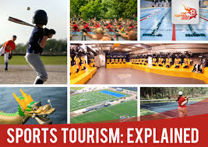

Business travel is a business trip for business travelers and official traveling on a different mission to travel as part of travel.Business involved in participating in meeting or seminars.To attend international exhibition or trade fairs.There are travel companies that provide business services such as fax and telephone communications,secretarial services, business meeting reception services,business facilities for business travelers,airport hotels and airplanes. 
Educational tourism is a new trend in the global travel industry and education tourism is the study and lerning which is the main purpose of traveling for tourism activities.The main purpose of travel is to lern about knowledge and experience on certain topic,rather than travel itself.The classification of education can explane types such as student exchange program,language schools ,and youth traveling . 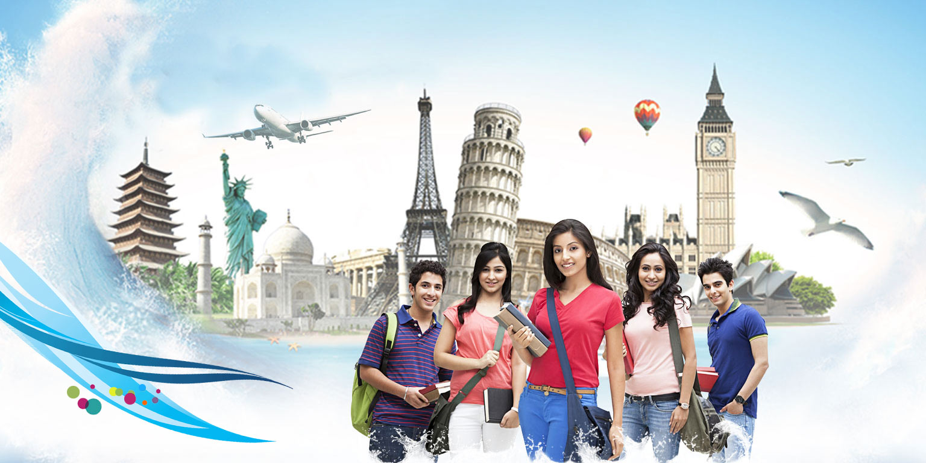 Cultural tourism is a subset of travel related to the tavel of tourists to a country or culture,especially the way people live in the geographic area.Religious and other help in their routing.cultural tourism includes travel in Thailand ,especially in historic cities or large cities and cultural facilities,such as Bangkok in Thailand.
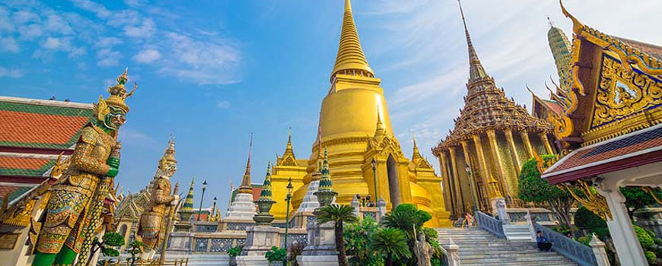
social tourism refers to program activities and activities that enable all segment of the population,especially young people ,families,retirees,individual with limited physical capabilities to enjoy tourism while simultaneously engaging with quality relationships.Between visitors and organizers.
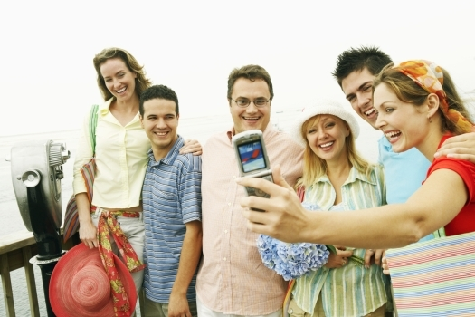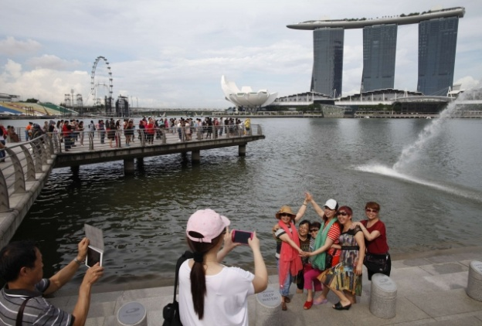

Medical tourism refers to people traveling to countries other than medical care in the past,often referred to as traveling from a developed country to a major medical center in a developed country .For home treatment Traveling abroad for medical treatment is estimated that thousands of migrants travel abroad to look after each year.Many factors influence the decision to seek medical treatment abroad.Some people travel for care because of the treatment.Cheaper than in other countries.Health and wellness travel is traveling to other cities for medical or health purposes.
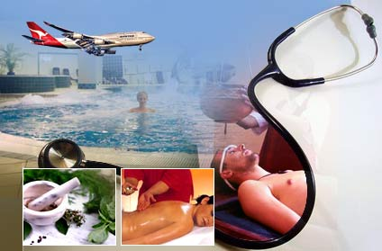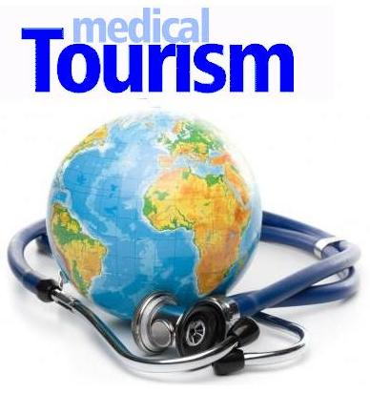

Adventure tourism is a type of specific tourism that involves exploring or traveling to remote areas where tourists should expect this expedition to grow rapidly while tourism is seeking unsual holiday
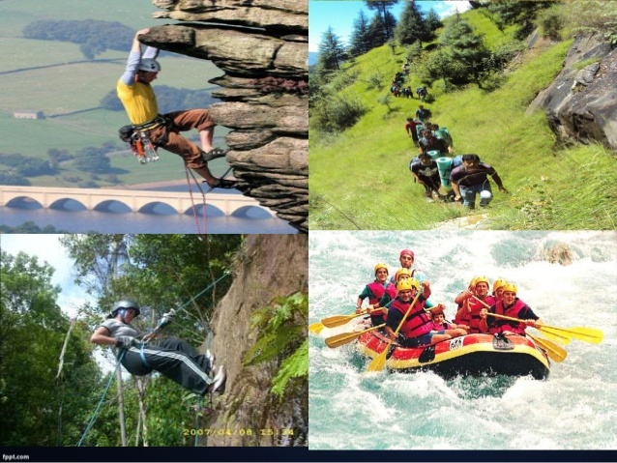

Nature tourism is responsible for traveling to natural areas,which helps to preserve the environment and improve the welfare of local people,which is a natural tourist attraction of the areas.
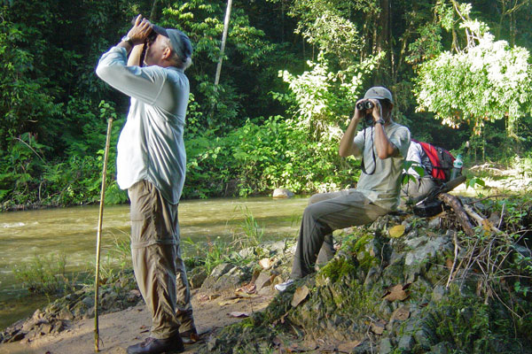

Question3 Describe the lodging accommodation and types of hotel accommodation.
Lodging accommodation is lodging is vacation accommodation is a type of accommodation that travels and stays more than a day from home ,necessitates rest,sleep,food ,shelter from cold temperatures,or luggage that rains and reaches home function.
The first of hotel accommodation is motel.Provides accommodation with free parking ,usually on the road side ,with rooms adjacent to an outside car park or city hotel.
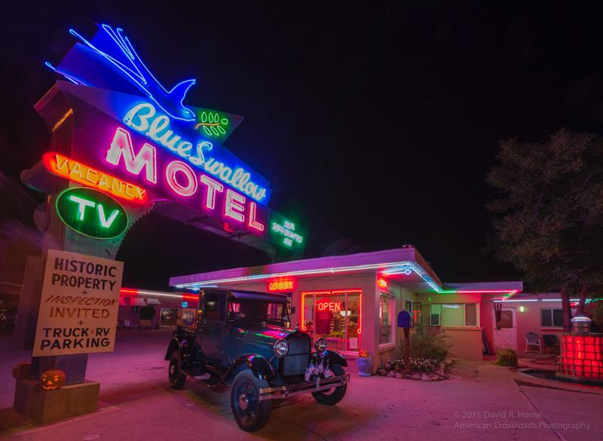

Inns is a hotel or tavern that provides accommodation for travelers.(A hotel in a small town with rooms for guests staying in the city is an example of a hotel.
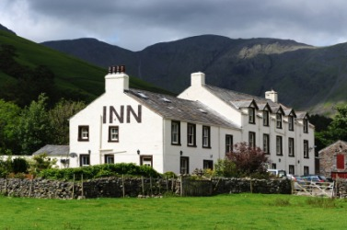
Bed and breakfast is sleep accomnodations for nights and breakfasts in hotels .Bed and breakfast is a private home where guest can stay at night in their own bedroom,owner or manager living in the house or in the living area,the public areas of the house such as the kitchen and living room.Stay with family at some breakfast included in the price.


The boutique hotel is a 5 star establishment that features the usual hotel amenities and amenities in a unique and exclusive style .These properties are generally small, offer excellent service .For example,boutique hotels in Singapore like Pegasus Boutique Hotel.
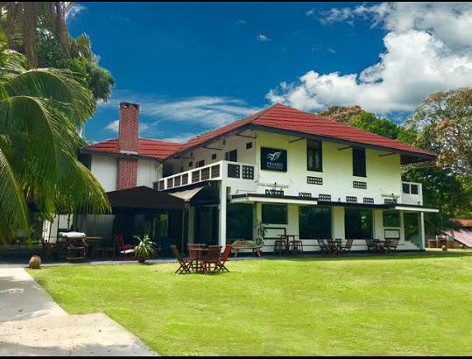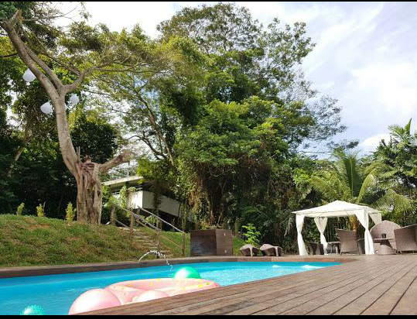

The eco hotel is a hotel or accommodation that has a significant environment and structural improvement to reduce its impact on the environment.The basic concept of the hotel is its environmentally friendly accommodation ,which follows the eco-friendly lifestyle of these hotels.Green is certified by an independent third party or by the state in which they are located.In addition,most of these hotels are offered as eco lodges because of their location usually in the jungle and design.They were inspired by the use of traditional methods such as villa sunset beach Lombok Island eco lodge in Indonesia.
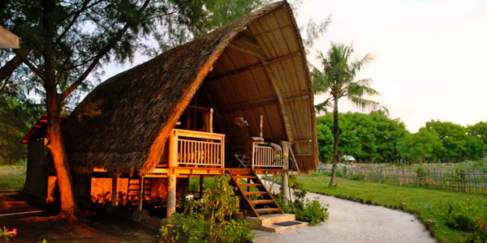

Question4 Explain the significant of entertainment in this industry. Entertainment industry in hospitality management is activities that make people have a lot of joyful time,especially during their free time,allowing them to relax and release pressure .In order, the activities people do during their free time expecting for work orcurrent situation.Briefly explain the five type of entertainment : The first type of entertainment is bar.It is a place where alcoholic beverages are sold,especially when they are sold and drunk,or where they are served by a retailer serving alcoholic beverages such as beer,and wine.Drinking cocktails and other beverages,such as soft drinks ,mineral water,often sell snacks like potato chips,peanuts for consumption pr premises.For examples,The sportsman ‘bar in orchard singapore 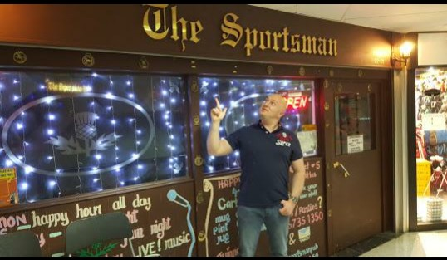 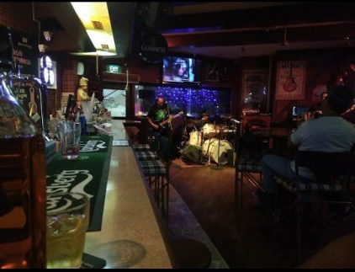
The second is night club.It is open at night usually serving food and drink,as well as for music and space for dacing often having a floor show .The night club also serving alcoholic beverages .in addition, night club included of a stage for live music and a DJ booth like Zion club in changkat bukit bintang kuala lumpur.
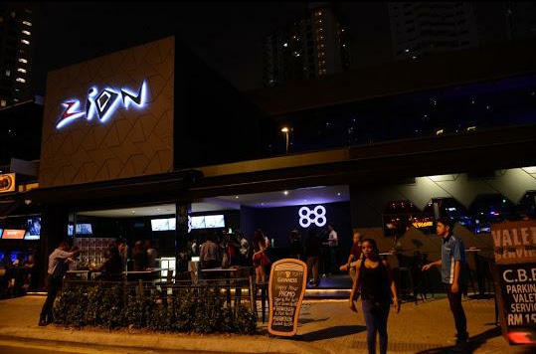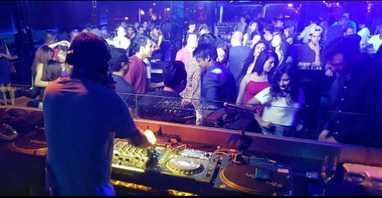
The third entertainment is cruise.The entertainment cruise is the nation’largest dining cruise company.It is boat trips,planning or usually to celebration such as wedding on the water,dinner with family,customized events on restaurant on the water with delicious food,entertainment and beautiful view. 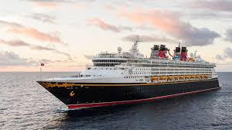
Sport and gaming is activities for people enjoyment .Sport and gaming also for recreational activities and involves one or more players.An activity providing entertainment or amusement a pastime .The playing of games can developed to teach to help solve problem or business situation and ability to attract attention by being for enjoyable or entertaining.
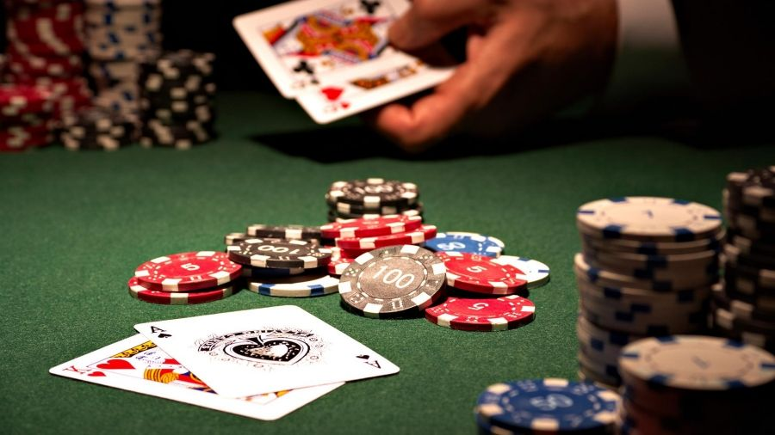

The last entertainment is marinas.It is supplies for yachts and small boat .A marinas does not handle large passenger ships.
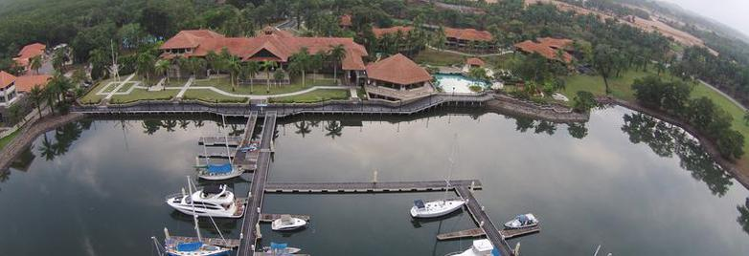

Conclusion The tourism is one of the largest money generating sector in the word .It is an ever-developing industry and this article will tell we about the tourism.Hospitality industry also largest in the world and hospitality is a heart odf business need to make money to survice and proper.Whenever we walk into a hotel,restaurant or an event ,all people need are attended to by people specializing in hospitality and touriam.

Appendix
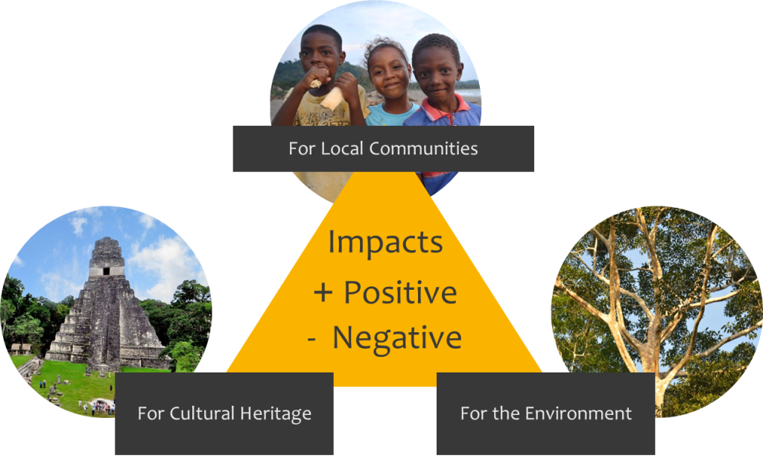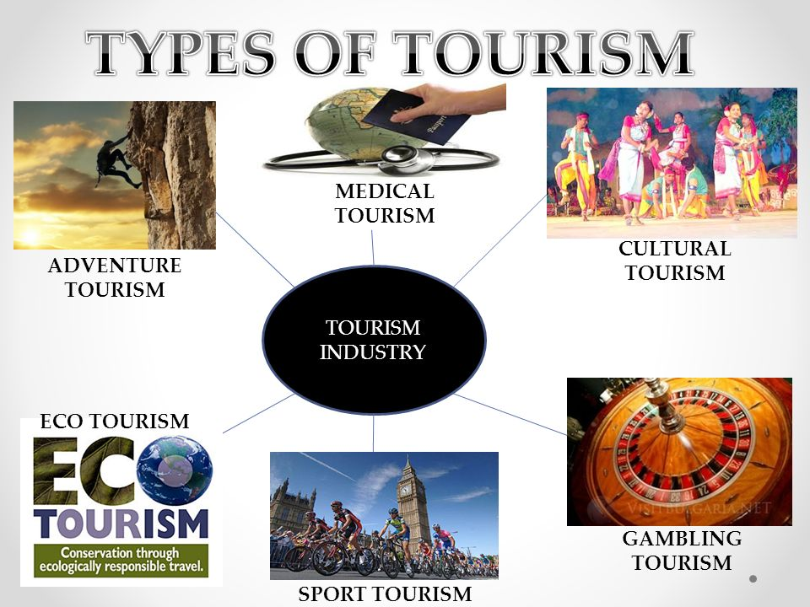
References 1.https://www.merriam-webster.com/dictionary/hospitality
2.http://www.solimarinternational.com/resources-page/blog/item/224-cultural-tourism-four-examples-of-how-it-works-for-destinations
3.http://culturalheritagetourism.org/
4http://www.abdtours.com/
5.https://en.wikipedia.org/wiki/Adventure_travel
6https://www.quora.com/What-is-social-tourism
7.https://en.wikipedia.org/wiki/Bed_and_breakfast
8http://medicaltourism.com/
9https://www.merriam-webster.com/dictionary/bar
10https://en.wiktionary.org/wiki/bar
11https://www.agoda.com/pages/agoda/default/DestinationSearchResult.aspx?asq=%2b7Gt30clBeDjIQ22WMHLXVZeq4%2f3WvR5GBPwbb0rQmNxee0X%2ff8l3g%2fjvFVWoZJViyux%2b4b410YIFrUdvSJu4A%3d%3d&type=1&device=c&network=s&adid=96897310146&rand=6217872722012254475&expid=&adpos=1t5&site_id=1410197&tag=3dfd4b9f-12d2-e89b-9331-f49a372b853d&url=http://www.agoda.com/city/kuala-lumpur-my.html&gclid=EAIaIQobChMIuPnN2MWd1gIVxw9oCh21bQ2WEAAYBSAAEgK_zPD_BwE&cklg=1
12http://www.tourismandmore.com/tidbits/sports-tourism/
13.https://www.facebook.com/ZionClubKL/
14https://en.wiktionary.org/wiki/bar
15.https://www.gadventures.com/

